MEASUREMENT PROBLEMS
KS1 – 2001 Paper
1.
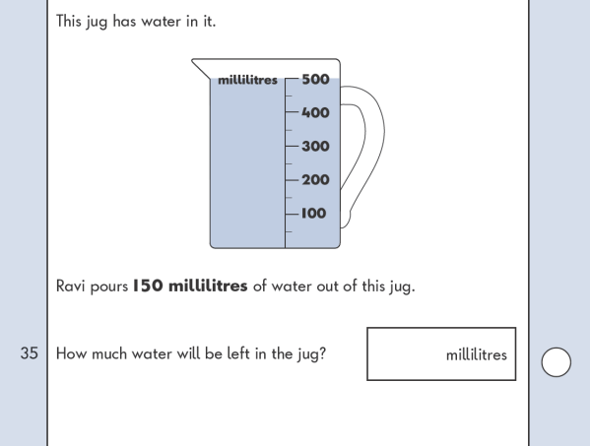
KS1 – 2005 Paper 1
2.
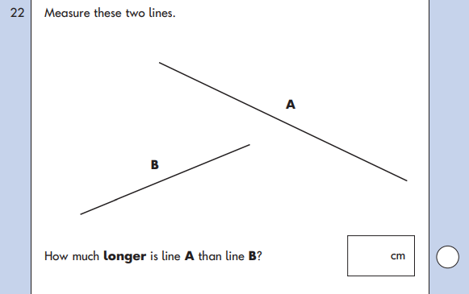
KS1 – 2005 Paper 2
3.
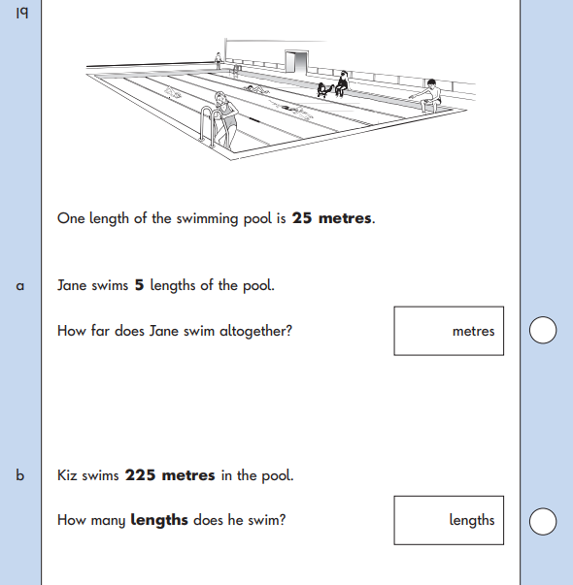
KS1 – 2007 Paper 2
4.
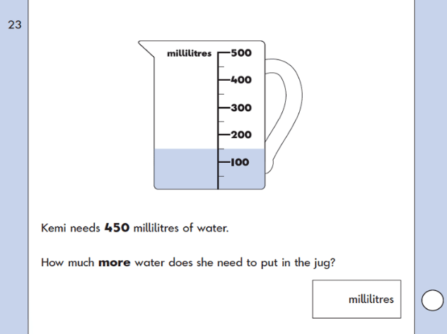
KS1 – 2009 Paper 1
5.

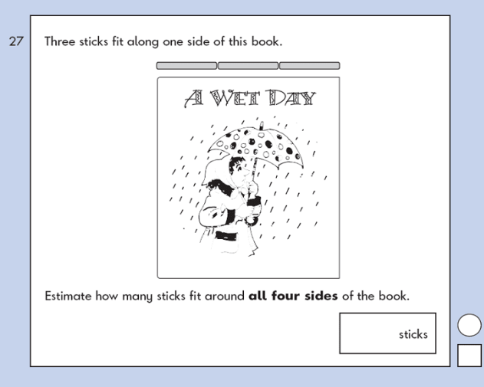
KS1 – 2009 Paper 2
6.

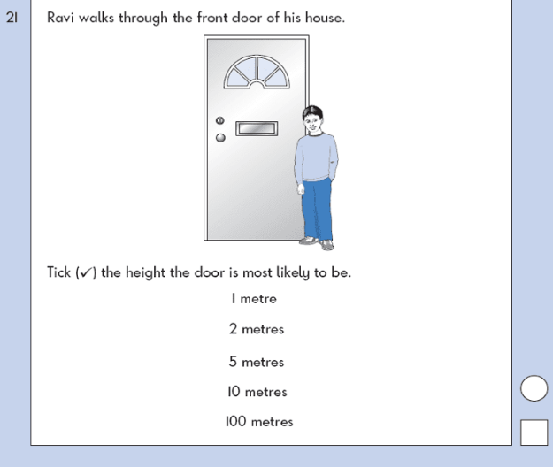
KS1 – 2016 Paper - Reasoning
7.

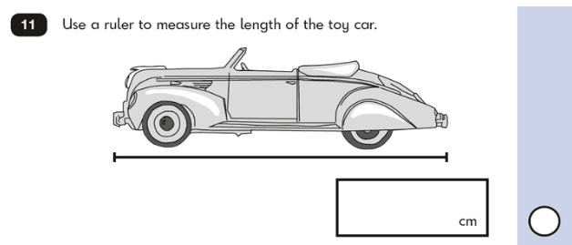
KS1 – 2017 Paper – Reasoning
8.
